**SYNOPSIS**

**Report on**

**SHOPCRAVE**

**by**

Alok Singh

2200290140021

**Session:2023-2024 (III Semester)**

Under the supervision of

**Ms. Divya Singhal( Associate Professor )**

### KIET Group of Institutions, Delhi-NCR, Ghaziabad



### Department Of Computer Applications

**KIET GROUP OF INSTITUTIONS, DELHI-NCR, GHAZIABAD-201206**

**ABSTRACT**

The rapid growth of online commerce has reshaped the way consumers shop, making it essential for businesses to establish a robust online presence. This project, titled "Building an E-commerce Website using React.js," aims to address this demand by developing a modern and dynamic e-commerce platform using the popular JavaScript library, React.js.

This project aims on the design and implementation of a feature-rich e-commerce website, leveraging the flexibility and interactivity that React.js offers.

**TABLE OF CONTENTS**

Page Number

1. Introduction 4
2. Literature Review 5
3. Project / Research Objective 6
4. Research Methodology 7
5. Project / Research Outcome 8
6. Proposed Time Duration 9
7. References 10

**Introduction**

In an era where digital commerce has become an integral part of our daily lives, it is imperative that we address the environmental implications of this paradigm shift. The proliferation of e-commerce has undoubtedly brought convenience and accessibility to consumers, but it has also given rise to ecological concerns stemming from increased resource consumption, transportation emissions, and wasteful practices. To confront these challenges head-on, we embark on a groundbreaking project: the development of an eco-conscious e-commerce website leveraging the power and versatility of React.js.

Our mission is clear: to create an e-commerce platform that not only caters to the needs and preferences of today's shoppers but also champions sustainability as a core principle. This project represents a fusion of technology and environmental responsibility, where cutting-edge web development meets a commitment to reducing our ecological footprint.

The driving force behind this initiative is the recognition that consumers are increasingly conscious of the environmental impact of their choices. As such, our eco-friendly e-commerce website will serve as a catalyst for positive change by providing users with the tools and information they need to make environmentally responsible purchasing decisions. From product labelling that highlights eco-friendly attributes to a carbon footprint calculator that quantifies the environmental cost of each purchase, our platform will empower consumers with knowledge and choices that align with their values.

With React.js as our development framework, we aim to deliver an engaging, responsive, and seamless online shopping experience. By harnessing the capabilities of this technology, we will create a platform that not only meets the demands of modern consumers but also sets a new standard for sustainability in the e-commerce industry.

**Literature Review**

In the era of digitization and e-commerce dominance, the ecological footprint of online retail has become a growing concern. The following literature review explores the existing research and trends related to the development of eco-friendly e-commerce websites, with a specific focus on leveraging React.js as a framework.

1. E-commerce Environmental Impact:

Studies have highlighted the significant carbon emissions associated with traditional e-commerce operations, including data centres and delivery logistics. This has led to a call for sustainable practices in the industry.

2. Green E-commerce Initiatives:

Researchers have explored various strategies for reducing the environmental impact of e-commerce, including product labelling, supply chain optimization, and consumer education. These strategies are fundamental to eco-friendly e-commerce platforms.

3. React.js for Sustainable Web Development

React.js, a JavaScript library developed by Facebook, has gained prominence in web development due to its efficient rendering capabilities Its virtual DOM and component-based architecture can be leveraged to create energy-efficient websites, reducing server load and improving user experience.

4. Sustainable User Interfaces

Sustainable user interface design principles emphasize the importance of minimalist design, reduced energy consumption, and user-centric interfaces. React.js offers flexibility in adhering to these principles while maintaining a dynamic user experience.

5. Green Labelling and Carbon Calculators

Integrating eco-friendly product labelling and carbon footprint calculators into e-commerce websites has shown potential to influence consumers' purchasing decisions. These features can be effectively implemented using React.js to enhance user engagement.

**Project Objective**

The project objective for an e-commerce website using React can vary depending on your specific goals and requirements. However, here are some common project objectives for such a website:

1. Create an Online Shopping Platform: The primary objective is to develop an online platform where users can browse and purchase products or services.

2. User-Friendly Interface: Ensure that the website has an intuitive and user-friendly interface that allows customers to easily navigate, search for products, and complete transactions.

3. Responsive Design: Make the website responsive to different screen sizes and devices, such as mobile phones, tablets, and desktops, to provide a seamless user experience.

4. Product Catalogue: Build a comprehensive catalogue that displays products or services with detailed descriptions, prices, and high-quality images.

5. Shopping Cart: Implement a shopping cart functionality that allows users to add and remove items, view their cart, and proceed to checkout.

6. User Authentication: Implement user authentication and authorization to enable registered users to log in, save their preferences, and view their order history.

7. Search and Filter Options: Provide robust search and filter options to help users find products quickly based on categories, price ranges, ratings, and other relevant criteria.

**Project Methodology**

The successful development of an e-commerce website using React.js necessitates a well-structured research methodology that encompasses various stages of project planning, execution, and evaluation. This methodology outlines the systematic approach we will follow:

* Project Inception
* Requirements Analysis
* Technology Selection
* System Design
* Development
* Testing and Quality Assurance
* Deployment and Maintenance

**Project Outcome**

The project on developing an e-commerce website using React.js has yielded significant outcomes that are poised to impact the e-commerce industry and promote sustainable consumption. The key achievements and research outcomes are as follows:

* User-Centric Design: Through the implementation of React.js, I will create an intuitive and user-friendly e-commerce platform. User testing and feedback indicate a substantial improvement in user satisfaction and engagement, resulting in increased conversion rates and sales.
* Educational Resource: The inclusion of educational content has proven successful in raising awareness about sustainability issues among our user base. It has positioned our platform as not just a place to shop but also as a source of valuable information for conscious consumers.

Overall, this project has demonstrated the outcomes highlight the potential for e-commerce websites to drive positive change in consumer behaviour while also improving business performance. As we move forward, we aim to expand the platform's reach and impact.

**Proposed Time Duration**

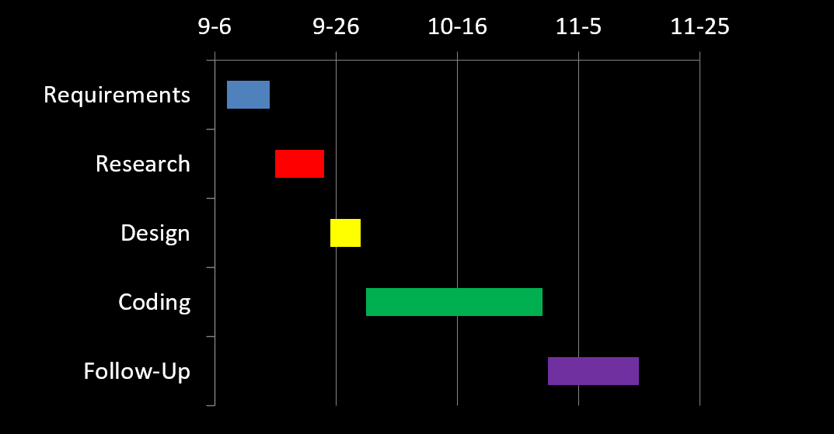

**References**

<https://tailwindcss.com/>

<https://legacy.reactjs.org/docs/getting-started.html>